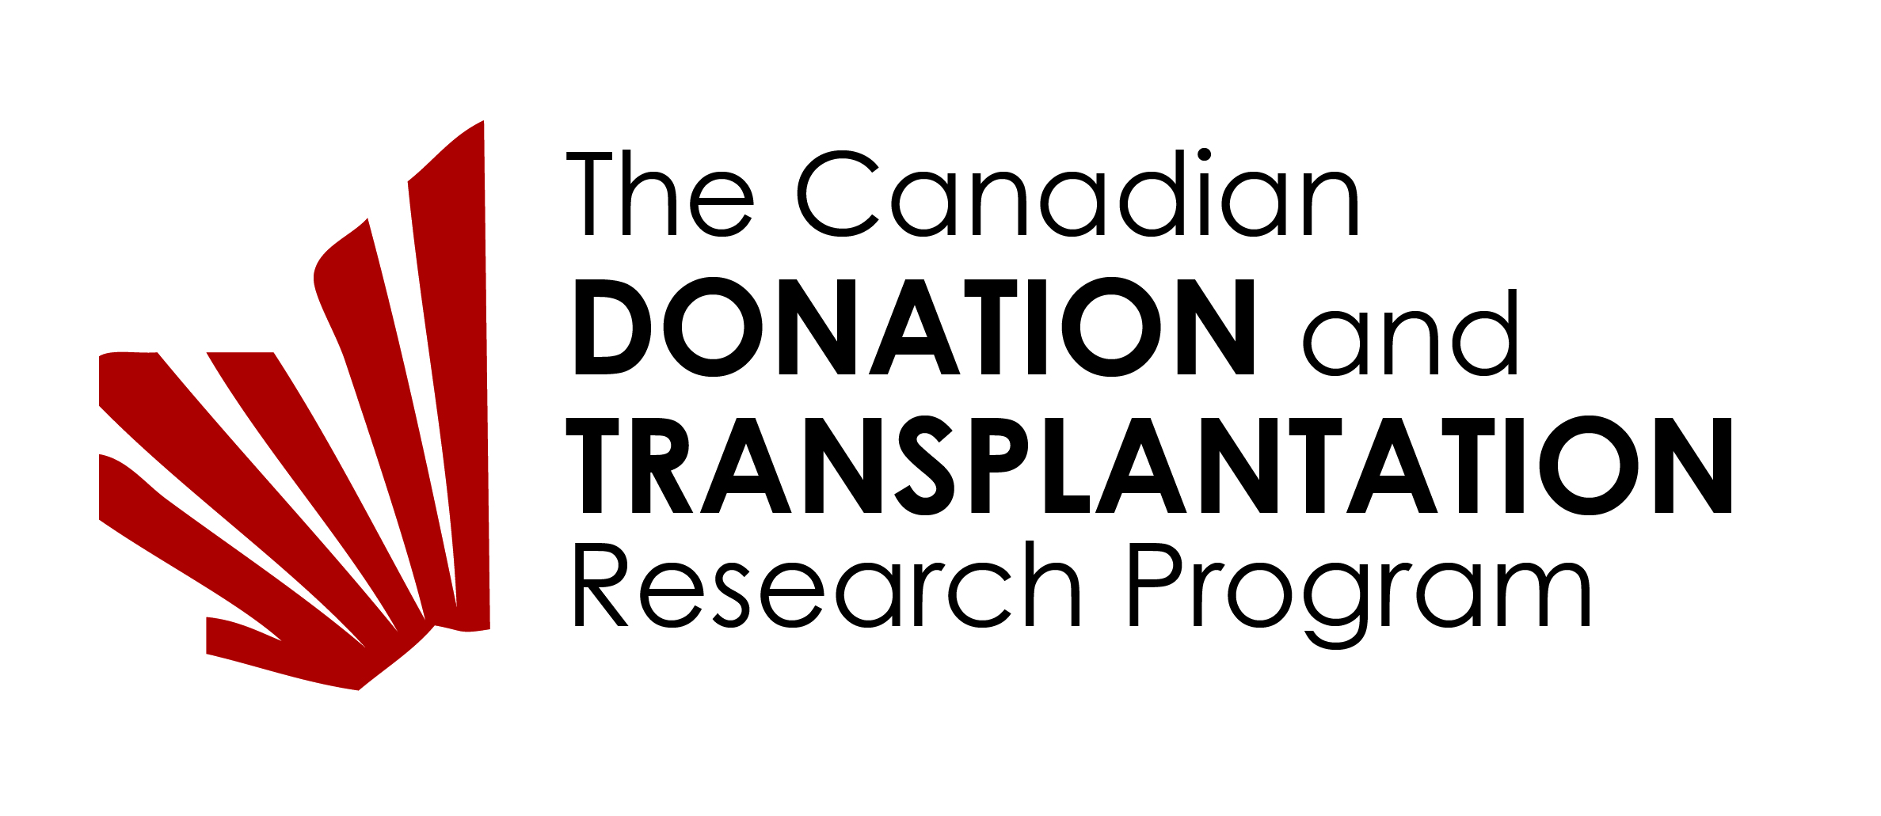
Academic TRAINEE APPLICATION FORM

Description of the Canadian Donation and Transplantation Research Program (CDTRP):
The CDTRP is a national initiative designed to increase organ and tissue donation in Canada and turn transplantation into a cure. The CDTRP is the first program in the world to integrate solid organ transplant, hematopoietic stem cell transplant, donation and critical care research communities together with patients and families in a transformative national research endeavor. The program is led by Drs. Lori West at the Alberta Transplant Institute at the University of Alberta in Edmonton and Marie-Josée Hébert at the Université de Montréal and brings together over 200 investigators and collaborators from across Canada to carry out research and develop resources to help Canadians living with a cell, tissue or organ transplant.
Description of the CDTRP Training Program:
The CDTRP Training and Career Development Program facilitates the development of competence in transplantation. The technical, clinical, ethical and scientific knowledge and competence needed to fulfill the aims of the CDTRP will be addressed using web-based media, educational conferences and mentorship. This program involves all members of the CDTRP and is composed of two components, the academic training program and the continuous education training program.
All academic trainees within the CDTRP are required to be members of the Training Program, to have an individual training plan with required content, and a mentorship plan for achieving their personal goals. CDTRP trainees are expected to be knowledgeable, dedicated, excellent scholars, with requisite experience for their level of training. They are expected to contribute to the growth and development of the network and actively engage in one of the 5 research Themes of the CDTRP.
Minimum Requirements:
- Eligibility for academic training at their Canadian University
- Must have a supervisor within the CDTRP
- Must have identified at least one additional mentor, preferably from a different Theme within the CDTRP
- Canadian citizenship or valid student/work visa
- Able to understand and work in English
Section 1 - Academic and Research Information:
Personal Data
Name
(Surname, First Name, Middle Initial)
Permanent Mailing Address in Canada:
Phone:
Email:
Primary Research Supervisor:
Mentor:
CDTRP Theme:
Personal research project title:

Academic Information:
Name of University are you registered with:
Name of the department/faculty:
Indicate the graduate program you are currently registered in: |  | (indicate start date and expected completion date)
 | MSc
 | PhD
 | Post Doctoral Fellow
 | Clinical Research Fellow
 | Surgical fellow
 | Research Associate

Academic History:
Degree | University/Institution | Country | Supervisor | Start Date | End Date

Research and other relevant work experience of applicant:
From: (YYYY/MM) | To:  (YYYY/MM) | Position | Institution/Company  City/Country | Supervisor's Name

University Academic Achievements (Prizes, Honors, Awards)
Prizes/Honors/Awards | Awarded by | Local/Provincial  National/International | Year Won

Applicant's Publications:
Attach a list of up to 5 of your most relevant publications.

Applicant's Accomplishments:
Outline any relevant academic, leadership, work and/or research accomplishments and/or experiences that you have accomplished to date. Contributions described in this section may include academic, non-academic and research achievements. Provide background information on major scholarships or awards and their significance.
Please use the space provided in this box.

Applicant's Career Development Plan:
Describe your career goal(s) and how the above listed achievements, publications, awards and related work and research experiences has prepared you to meet your career aspirations. Also, outline the reasons for undertaking the current program of study as it relates to your career progression, your specific career objectives and how your future career plan(s) will be enhanced by the proposed research training experience outlined in this application. Clearly describe and justify the rationale behind the selection of the mentorship advisors and how the mentors relate to your career development plan.
Please use the space provided in this box.

Section 2 - Applicant’s Research Project
The applicant is to provide a brief description of their current or proposed research project. The applicant should indicate how they would like to integrate this project into the CDTRP and what non-financial support they would like to receive to complete the project.
Please use the space provided in this box.

Section 3: Electronic Signatures
Acknowledgement of support from Supervisors (original or electronic signature), and Mentors (may be obtained by email and attached to the application)
Candidate:
Primary Research Supervisor:
Mentor:

Section 3: Letter of Reference
Identify the one individual who has been asked to submit a letter of reference on your behalf. The primary research supervisor may be your one reference.
Letters of reference should highlight the applicant’s strengths as they relate to the suitability and experience for the proposed work in this training environment (e.g. originality, technical ability, demonstrated skills, judgment, critical skills, etc.) and the benefit that the proposed experience would provide the applicant towards their career goals.

Section 4: CDTRP Mentoring Plan (to be completed in discussion with the Mentor after acceptance into the training program)
Name of the Mentor:
Mentoring goals for the 1st year:
Meeting Schedule:
Proposed benefit of the mentorship:

The mentor can be selected after acceptance into the CDTRP training program if you need help identifying the ideal match

