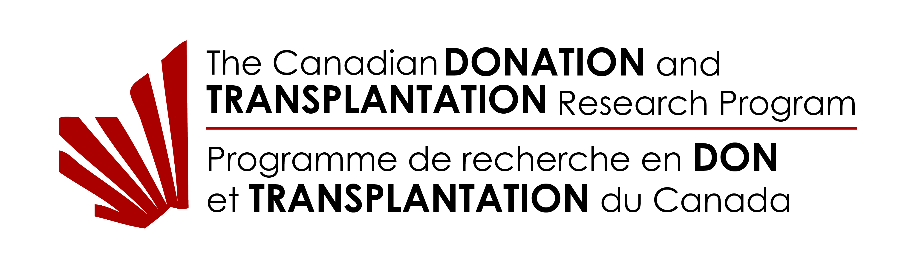

Request for CDTRP support

DEADLINE to submit request to the CDTRP: 14 days before the letter is required, unless otherwise stated. Please submit ONE request per project per grant competition

- APPLICATION INFORMATION
1a. Grant competition:
1b. Date of grant submission deadline:
2a. Project Title:

2b. Is this project new to the CDTRP?  yes no | How many years of Funding are you requesting?
3a. Name of Principal Applicant | 3c. Name of Co-applicant(s)
3b. Position/rank, department and/or faculty of principal applicant

4. Contact information of principal applicant

Telephone: E-mail:

5a. Is the principal applicant an Investigator in the Canadian Donation and Transplantation Research Program (CDTRP)?

Yes No

5b. If not, name of CDTRP co-applicant(s):

6. Identify the primary CDTRP Theme affiliation (if funded, the project will become part of that Theme)

Primary Theme Secondary Theme (optional)
Theme 1: Create a culture of donation
Theme 2: Inform universal practices for donation
Theme 3: Engineer and allocate better grafts
Theme 4: Tailor an optimal immune system for each patient
Theme 5: Restore long-term health

7. Attach a Summary of the Research Proposal that will help us determine if the proposed research addresses the One-Transplant-For-Life vision – fulfilling every donor opportunity and turning transplantation into a cure. This information will be shared with the CDTRP Management Team and the relevant Theme leads. Maximum length: 1 page

8. Attach a lay abstract (max. 2000 characters) that can be used to explain your proposal to the general public. If funded, this information could be posted on the CDTRP websites. (Can be the same as your ResearchNet Lay Abstract)

B. REQUESTED RESEARCH RESOURCES
Indicate which CDTRP resources you are interested in including in your grant application and provide the requested details in the form below.

- Economic, Legal, Ethics and Social analysis
  - To request this support, provide a ½ page description below of the proposed analysis, describing the additional value it brings to the overall study. If you have already identified a collaborator to do this work, include the name of the collaborator and their institution.
  - The CDTRP can provide up to $10,000 as a cash contribution to help cover the cost of an economic, legal, ethics, or social analysis to accompany your main study. This analysis is intended to enhance the scope of your primary study and provide further understanding on the social and economic impact of the research. This funding can be used to support your existing collaborations, or we can help you identify potential collaborators to work with you. The CDTRP will provide this $10K directly to your collaborator to complete this analysis.
- Patient-Researcher Partnerships
  - Indicate below the anticipated patient/family partners participating on this project, and a scope of their involvement.
  - CDTRP can provide up to $500 per application to support the integration of a patient/family partner on your research team (10 hours, $50/hr). This patient/family partner would be a fully integrated team member that would bring their lived experience and patient expertise to enhance the study. The CDTRP can also provide full travel support for the partner to attend the CDTRP Annual Meeting (avg $1000). The patient/family partner would also be part of our Patient-Researcher-Partnership Platform and have access to training and mentorship.
- Trainee Support
  - Indicate below the anticipated number of CDTRP trainees that will be participating on this project.
  - Any CDTRP trainees identified in your application must apply to and fully participate in the CDTRP Academic Training Program, which provides your trainees with access to our national curriculum, training webinars, structured mentorship program, and up to $1000 each to reimburse travel to the CDTRP Annual Meeting.
- Data Safety Monitoring Board (DSMB)
  - Provide a short ½ page description below explaining why your study requires the use of a DSMB
  - CDTRP supported clinical studies can request use of the independent Data Safety Monitoring Board (DSMB) to help monitor progress and adverse events and provide arms length advice on patient safety and trial accrual. The CDTRP can provide access to the DSMB as an in-kind resource to your study ($2000 value).
- Access to Biomarker, Immune Monitoring and Artificial Intelligence expertise
  - Explain below what type of resources you are looking for and how we can help you access these resources
- CDTRP Central Management Team and Communication Resources
  - Describe your resource needs below from the Management Team and how they would help with your project
  - You can include the support and resources from any of our central staff to support your CDTRP study and can include a portion of our time as an in-kind resource. You can also request access to the CDTRP teleconference and webinar systems, space on our website to promote your study and share information, access to our CDTRP Dropbox, and central communication to all members of the network (all in-kind resources).
- Small Meeting Support and Knowledge Dissemination
  - Indicate below the purpose, size and timing of the proposed meeting.
  - The CDTRP can offer to help organize small research meetings as part of the CDTRP Annual Meeting and can help cover the cost of the meeting space and the AV (in kind). We can also help promote the results of your study through our monthly Theme calls, on Sosido, on our website and social media platforms, and at our annual meeting (in kind).
- Development and production of FAST FACTS
  - Explain below the proposed topic and scope of the FAST FACT
  - The CDTRP can work with you to include the production of FAST FACTS (www.cntrp.ca/fast-facts) as a research output for your study. As an in-kind resource, the CDTRP can assemble a collaborative team, create the production design, translate into French or English, and promote to our community

See additional information about these specific resources on our website: www.cntrp.ca/research-resources

PROVIDE ADDITIONAL INFORMATION HERE (Patient #, Trainee #, etc)

C. Address for Submissions

Please send completed requests for CDTRP support, as a single PDF file with both the filename and email subject as:
LastName - CDTRP SUPPORT REQUEST, to:

David Hartell
Executive Director
Canadian Donation and Transplantation Research Program
davidhartell@cntrp.ca

and cc

Leanne Stalker
Research Manager
Canadian Donation and Transplantation Research Program
lstalker@cdtrp.ca

